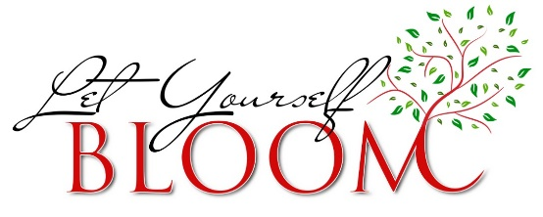

**Parent Advisory Board Meeting Notes**

**Date: Tuesday, November 1, 2016**

**Time: 8:00am**

**Location: Room 103**

*(Notes were taken by Melissa. Therefore, any ‘I’ found below refers to her.)*

* October Meeting Follow-Up
  + We used input from both the student advisory and parent advisory meetings in October to schedule a reckless driving assembly in December. We shared that a member of Geisinger Medical Center’s trauma team would be presenting the information to all of our students.
* Parent Conference Day- November 14
  + Attendees were asked for thoughts regarding the upcoming parent conference day and how we can encourage more participation by parents.
  + Some parents shared that they would prefer to know how many teachers (and which ones) will attend prior to the meeting.
  + Parents also shared that they would like the meetings scheduled at least one week in advance to allow for better preparation.
* Commencement Caps & Gowns
  + In an effort to use one gown that includes both red and white for all students, parents were shown three potential options for our commencement gowns. We discussed the difficulty when using a white gown due to the see-through nature of the fabric. Though one gown had more of both colors, it was compared to a choir robe. The first option, with was a red gown with white trim at the wrist was selected as the parent favorite. This information will be shared when a recommendation is made to the school board later this month.
* Improving Parent Involvement
  + Parents shared that they would like to be more involved but are not sure how they can be.
  + Some would like to receive more written correspondence from the school.
  + Parents would like the school to use the One Call notification system for more events such as evening meetings and parent advisory meetings. They also shared the need for more Remind 101 text messaging alerts.
* Career Development
  + As part of the discussion regarding parent involvement, parents shared concerns with the amount and type of career development at the high school. They shared a number of ideas. These ideas, which generated further discussion, are listed below:
    - Career Day including people from various trades each year
    - Senior Interview Day to include mock interviews and/or etiquette for seniors
    - Discussions with admissions officers from local post-secondary institutions
    - More public speaking opportunities for the students
  + I shared that the guidance counselors and I would be traveling to the Milton High School later that morning for a Career Fair visit. I also shared upcoming meetings with the K-12 guidance staff and the Chamber of Commerce to discuss career development.
* Additional Concerns
  + Homecoming Weekend
    - Some questioned why BHS Homecoming is held the same weekend as BU Homecoming due to the traffic issues and scheduling issues with local restaurants that occur. Most understand the advantage of having both homecomings in the same weekend, especially the parade.
    - While it was good to see floats in the parade again this year, some requested that the information be shared in multiple ways to include more students.
  + Prom Dates
    - There was some concern that the prom date would conflict with the Renaissance Fair in town. After checking both dates, we determined that there would not be a conflict.

**Next Meeting: Wednesday, January 11, 2017 at 8:00am**